Learn English Basics

Appearances - How to describe someone in English

Height | Build | Hair | Eyes | Type of hair | Complexion | Other features

HEIGHT
 | 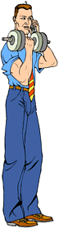 | 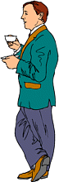 | 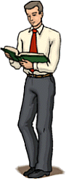
 | He is tall. | He is short. | He is average / normal / medium height.
+ | He is very tall. | He is quite short. | He is relatively normal height.

BUILD
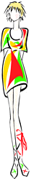 | 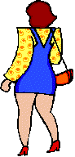
She is skinny. (negative) | She is fat. (negative)
She is anorexic. (medical) | She is tubby. (negative)
She is underweight. (negative) | She is overweight. (negative)
She is thin. (negative) | She is plump. (neutral)
She is slim. (positive) | She is stocky. (neutral)
She is slender. (positive) | She is bonny. (positive)
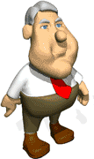
!Note - if a man is fat (especially round the waist) we often say he has a beer belly.

HAIR
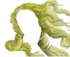 | 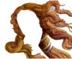 | 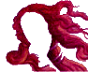 | 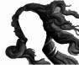 | 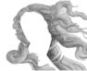
blonde/fair hair | brown hair | red hair | black hair | grey hair
blonde | brunette | redhead | - | -

EYES
 | 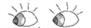 |  |  | 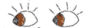 | 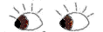
 | grey eyes | green eyes | blue eyes | brown eyes | dark eyes
 |  |  | 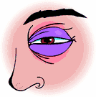 | !Note!  This is a black eye!

TYPE OF HAIR
 | 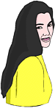 | 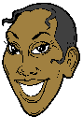 | 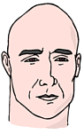 | 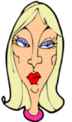 | 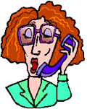 | 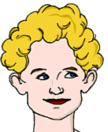
 | She has long hair. | She has short hair. | He has no hair. = He is bald. | She has medium length hair. | She has medium length hair. | She has short hair.
+ | She has long, black hair. | She has short, black hair. | - | She has medium length , blonde hair. | She has medium length, red hair. | She has short, blonde hair.
++ | She has long, straight, black hair. | She has short, straight, black hair. | - | She has medium length, straight, blonde hair. | She has medium length, wavy, red hair. | She has short, curly, blonde hair.
or | Her hair is long, straight and black. | Her hair is short, straight and black. | - | Her hair is medium length, straight and blonde. | Her hair is medium length, wavy and red. | Her hair is short, curly and blonde.
+ |  |  |  |  | She wears glasses.

TYPE OF COMPLEXION
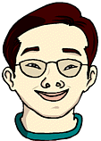
He is asian. He has light-brown skin. |  | She is black. She has dark skin. |  | He is white. He has fair skin. |  | She is white. She has lightly tanned skin. |  | She is white. She has very pale skin.

OTHER FEATURES
Can you spot the named feature?
 | 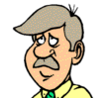 |  | 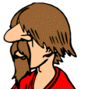 |  |  |  | 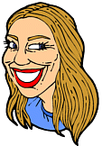
 | moustache |  | beard |  | chin |  | forehead |  | nostrils
 |  |  |  |  | 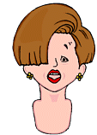
 | eyebrows |  | cheeks |  | fringe |  | lips |  | teeth

SOME FEATURES (IT MAY NOT BE POLITE TO MENTION THEM)
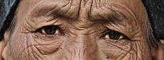 | 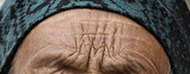 | 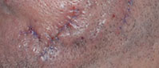 | 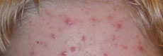
crow's feet  aka laughter lines  a sign of maturity that appear at the corners of the eyes | wrinkle(s)  a sign of maturity which can appear on any part of the body, often on the forehead | scar(s)  any part of the body where a wound has healed | spot(s)  aka pimple(s)  any part of the body, but most noticeable on the face

Note !

BALD, BLACK, BLONDE, BLUE, BROWN, CURLY, FAT, GREY, LONG , MEDIUM,
OVERWEIGHT, PALE, PLUMP, RED, SHORT, SKINNY, SLIM, STOCKY, STRAIGHT, TALL, TANNED,
THIN, WAVY AND WHITE

ARE ALL ADJECTIVES - THEY DESCRIBE THINGS

VERY, QUITE AND SLIGHTLY

ARE ALL MODIFIERS - THEY CHANGE (MODIFY) THE ADJECTIVES.

AND DON'T FORGET, BEING ABLE TO DESCRIBE PEOPLE IS A VERY USEFUL SKILL:-
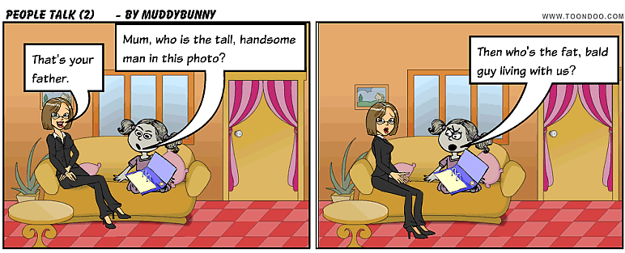
By muddybunny | View this Toon at ToonDoo | Create your own Toon
Basic English
- See more at: http://www.learnenglish.de/basics/appearances.html#sthash.8eHQpXvq.dpuf

